De-Spooking Clinic
Training Clinic for Civilians & Their Show/Trail Horse

Come and experience a Mounted Police Training School and Train with
Bill Richey, Director of National Mounted Police Services, Inc.
P.O.S.T. Credit Hours for Law Enforcement, S&R Teams
& Sheriff Posse Members

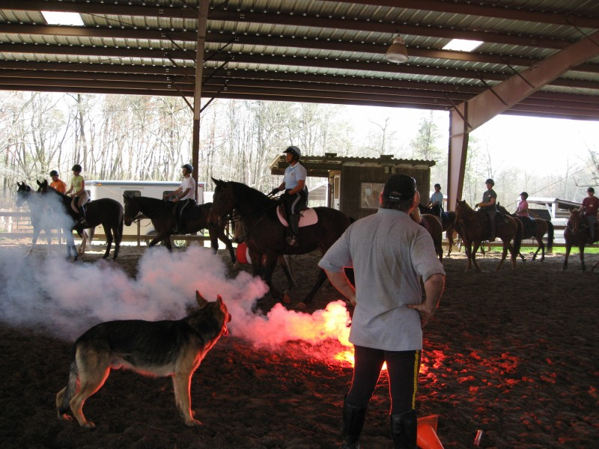

So you have a great horse. The day is a wonderful day for the show or a trail ride and you know you could have a great time, maybe even win, if only your horse would just settle down. It seems your horse always gets excited and nervous on show/event day and looks for any reason to spook. You’re all too familiar with that jumpy, spooky, can’t stand still, can’t get a grip day, that you have come to expect.

Believe it or not, there is a cure!

Think about it this way, if Arabs, Thoroughbreds, Warm-bloods, Quarter Horses, Appaloosas, Paints and any other kind of horse can be trained to be police horses, there is no reason your horse can’t be taught the same things. The fact is training a horse to be “spook proof” is just another training method. Like all other training methods, it required a working knowledge of techniques used by, in our case, police training. And like all training, with enough practice your horse will learn to trust you and “go forward” through whatever you tell him/her to go through with little or no resistance.

Two Day Clinic in Your Area
Freedom Farm USA (Indoor Arena)
850 Monmouth Road
Cream Ridge, N.J. 08514
www.FreedomFarmUSA.com

Clinic date: April 2 through April 3, 2011
Time: 9:00 am to 5:30 pm

For Reservations, Stabling and Lodging Information contact
Rosanne Vaccaro at 732 995-6552 or
e-mail: Balanceride@optonline.net

$275.00 Per Rider for two day clinic
$25.00 Per Day Auditor Fee
** Reservations & Deposit required for clinic participants **

